Lesson Overview

LA-STEAM Cross Curricular Lesson-Windmills

Students will:

- Read and study The Fabulous Perpetual Motion Machine
- View videos and images of perpetual motion machines, windmills, windfarms, dams and hydro-electric turbines.
- Work in groups of 3 or 4
- Build a class standard Windmill
- Calculate the Power output of the Windmill
- Make modifications to the blades of the Windmill to create more power
- Create a summary of the process in the form of a comic using and understanding the literary elements of Character/Plot/Rising Action/Climax/Resolution
- Extensions: Create a water turbine and measure the power output. Write a short paragraph comparing and contrasting the machine created by the students in the play and the windmill machine created in the classroom experiment.

Language Arts: CLOSE study of Perpetual Motion Machine
Science: Understanding the Sun’s energy and it’s effect on the Earth
Technology: Study of simple machines
Engineering: Building and Modifying a machine
Art: Creating a comic or graphic novellete (create with templates from makebeliefs.com or pixtons.com or just by good old fashioned pencil and paper)
Math: Calculating and converting relevant units of measurement

*Visuals and Diagrams Located in Powerpoint

LA+STEAM Windmill Lesson

Topic: Energy and Motion (The Fabulous Perpetual Motion Machine)

Testable question: How can the blades of a wind turbine be modified to create more power?

Lesson question: How is the sun’s energy transferred to create electrical energy?

or

(How is the Sun’s energy transferred to and used by a windmill?)

Pages From core text:

- The Fabulous Perpetual Motion Machine
- Power in the Wind

Common Core Reading and Writing standards:
RL1,RI2, RI3,W2,W4,W5
RI.5.7 Draw on information from multiple print of digital sources…
SL.5.5 Include multimedia componets and visual displays in presentations when appropriate

Background Knowledge:
Students need to know that the sun’s energy is responsible for the uneven heating of the earth which creates wind. Wind energy is created by solar energy.

NGSS standards:
3-5-ETS1-2 Engineering Design
3-5-ETS1-1 Engineering Design
5-ESS3-1 Earth and Human Activity
5-PS3-1 Energy (focusing mainly on the crosscutting concept that Energy can be transferred in various ways and between objects).

Math Skills explored and practiced:

- Conversions (joules to watts)
- Collecting and recording data
- Graphing
- Multiplying and Dividing

Writing and Art Assignment:

Students will create a comic book story of their group’s process of discovery during the windmill project. The comic story must have these elements:

- Setting
- Intro to characters (students)
- Problem
- Rising Action
- Climax
- Resolution

(This activity lends itself to the understanding of the writing convention of dialogue and how it serves as a vehicle for plot advancement).

Lesson Resources to be used at teacher’s discretion in an order that makes sense.

- Instructional Text #1: The Fabulous Perpetual Motion Machine (Pearson©)
- Instructional Text #2: Windmill Project PDF http://www.education.com/pdf/engineering_windmill/
- Instructional Text #3: Power in the Wind http://learn.kidwind.org/learn/wind_basics_power (this is a huge resource to be explored. Choose what suits your level of involvement in this project)
- Instructional Text #4: How to construct a windmill and calculate its power
http://science.wonderhowto.com/how-to/construct-model-windmill-and-calculate-its-power-259781/

Activities

- CLOSE reading of the play The Perpetual Motion Machine
- Build a windmill
- Calculate Power of windmill
- Modify the Windmill
- Create a comic that represents (in story form) the group’s process and experience during the windmill project. (Students will use a collective and agreed upon story of their experience, however, each student will create their own comic).
- Extension LA lesson: Write a short paragraph comparing and contrasting the machine created by the characters in the play to the windmill machine created by the group.

Struggling readers and Language learners

- Groups will be heterogenious and peer buddies will be assigned to struggling readers and language learners.
- Teacher will pull small groups of stuggling readers and language learners for extra support while other students are working independently
- Modify writing assignment by giving a comic template and sentence/dialogue starters.

Video Support:

Perpetual motion machines (background music annoying)
https://www.youtube.com/watch?v=287qd4uI7-E
https://www.youtube.com/watch?v=FO566k4nA3g

Why does the wind blow? https://www.youtube.com/watch?v=xCLwbqmacck

A working windmill tour
https://www.youtube.com/watch?v=t9KI2g-r8rA

Marine and hydrokinectic energy
https://www.youtube.com/watch?v=ir4XngHcohM

Hydropower
https://www.youtube.com/watch?v=tpigNNTQix8

Wind turbines
https://www.youtube.com/watch?v=tsZITSeQFR0

How to construct a windmill and calculate its power
http://science.wonderhowto.com/how-to/construct-model-windmill-and-calculate-its-power-259781/

MacGyver Windmill Kit (I wouldn’t buy this kit because of the expense but the ideas of construction are well illustrated and the video of the kids working together is valuable).
http://store.kidwind.org/catalog/macgyverwindmill

Core Diagrams (other visuals in ppt):
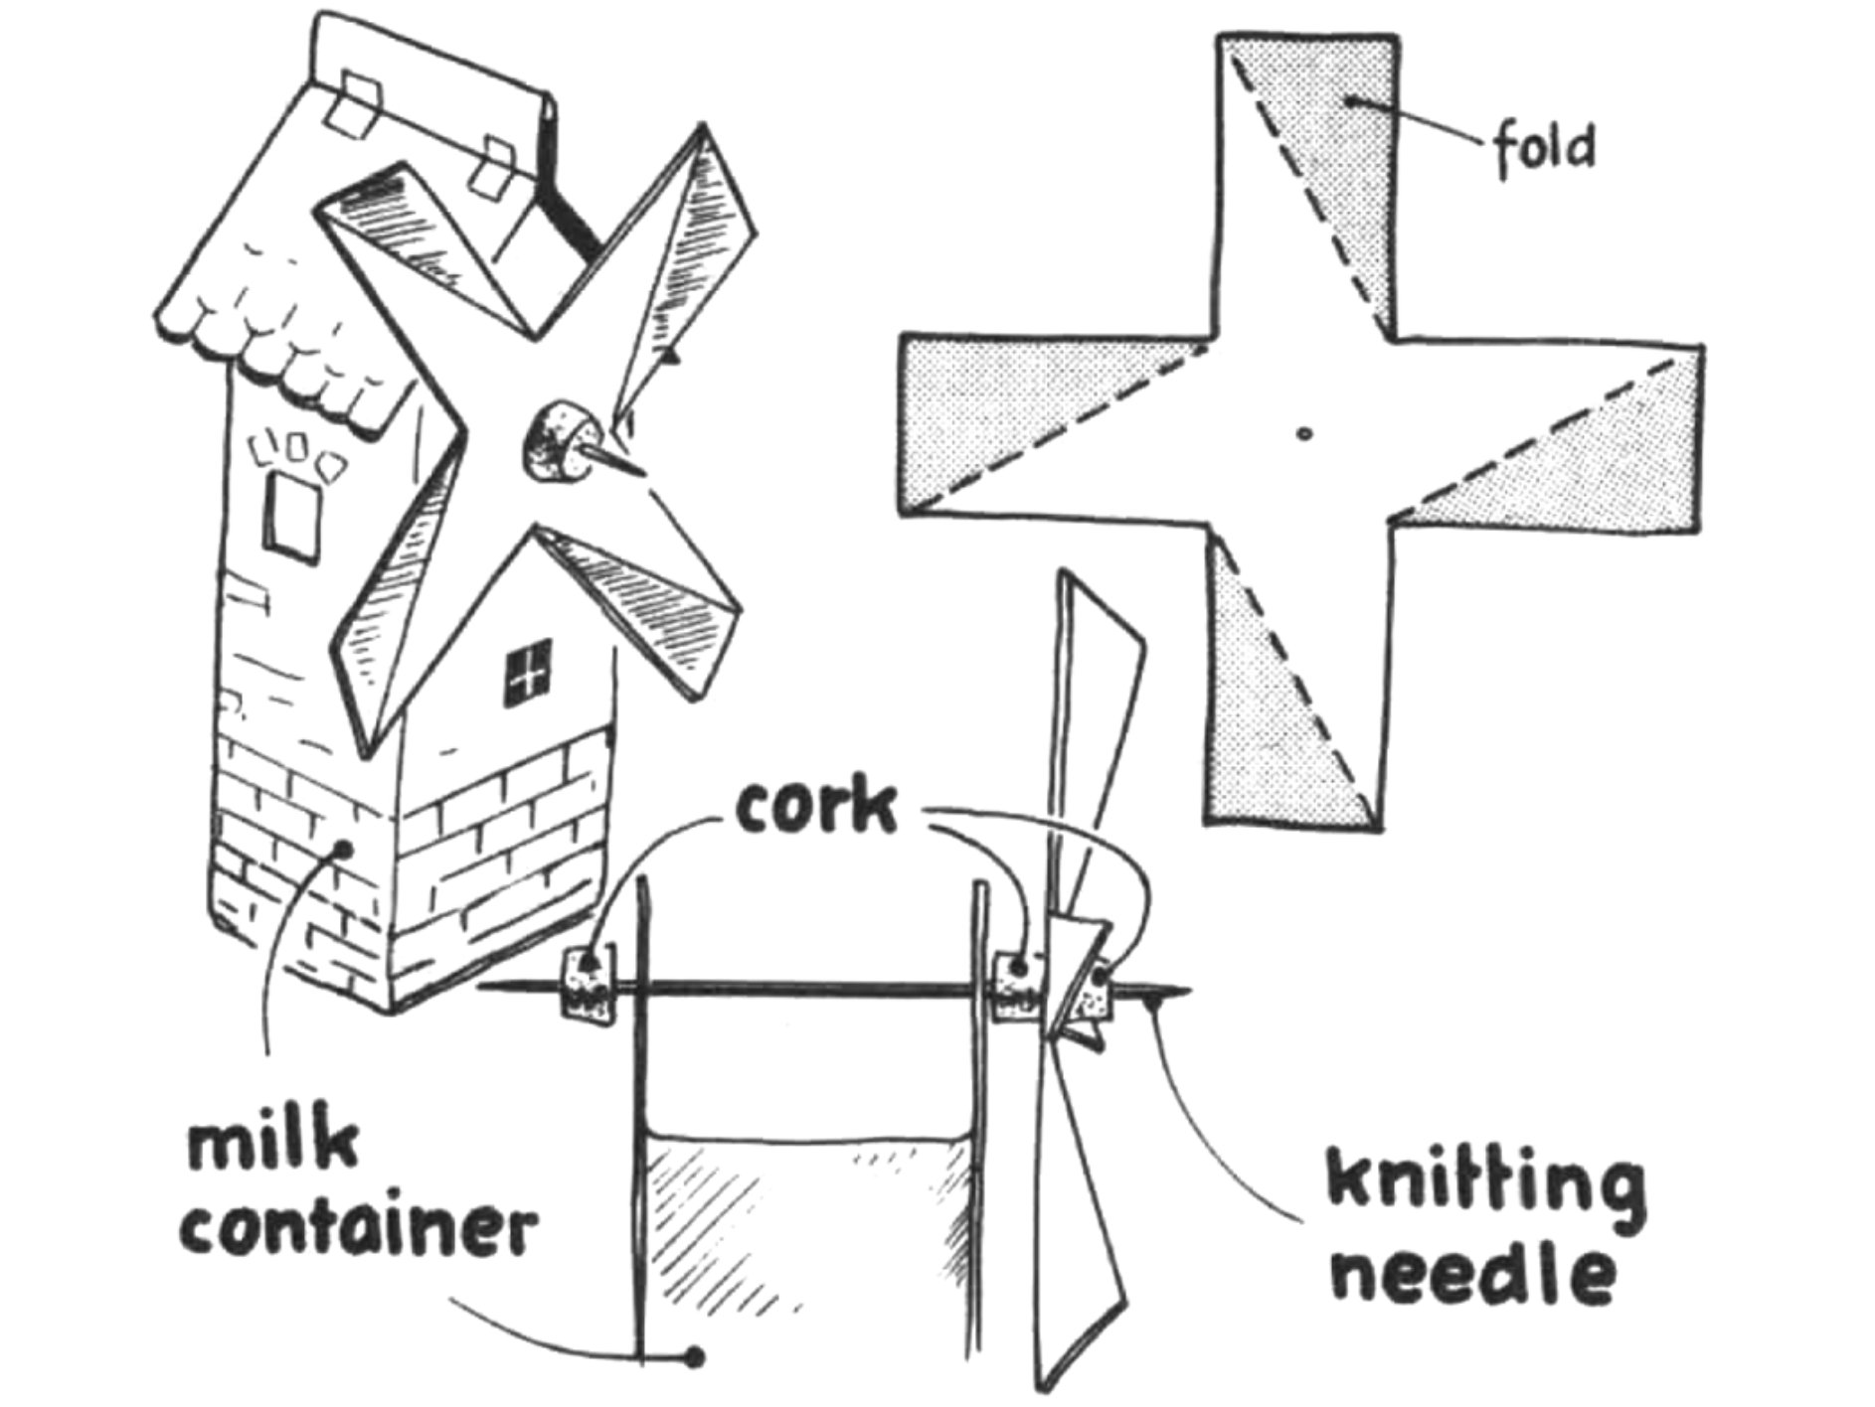
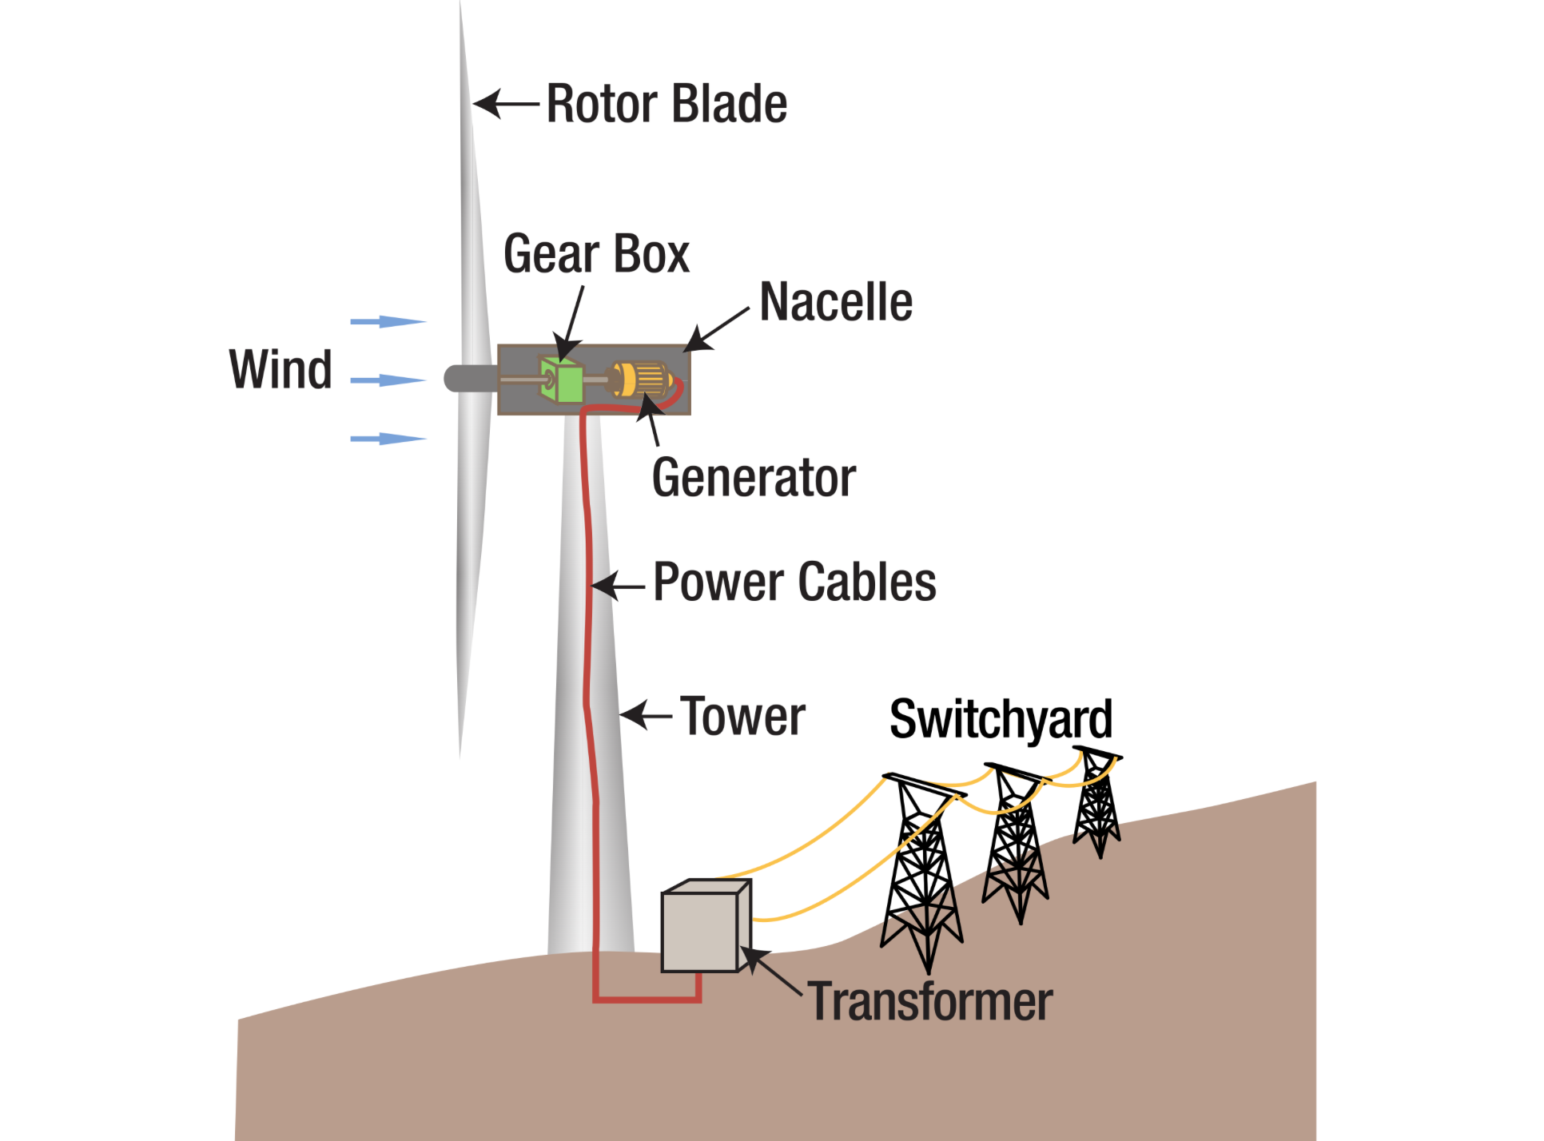

Another Contruction Option!

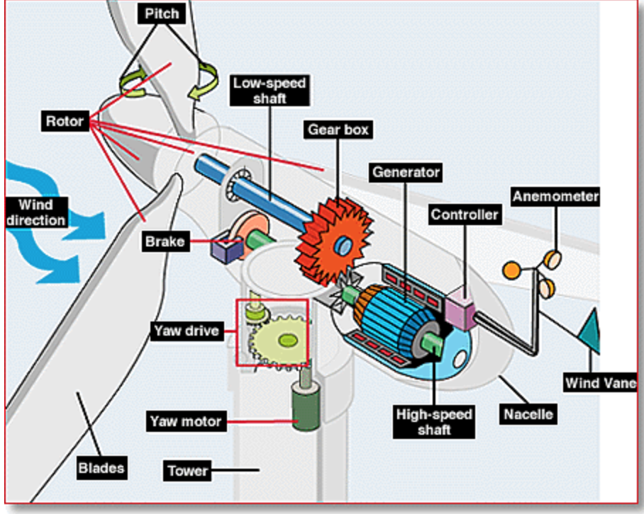

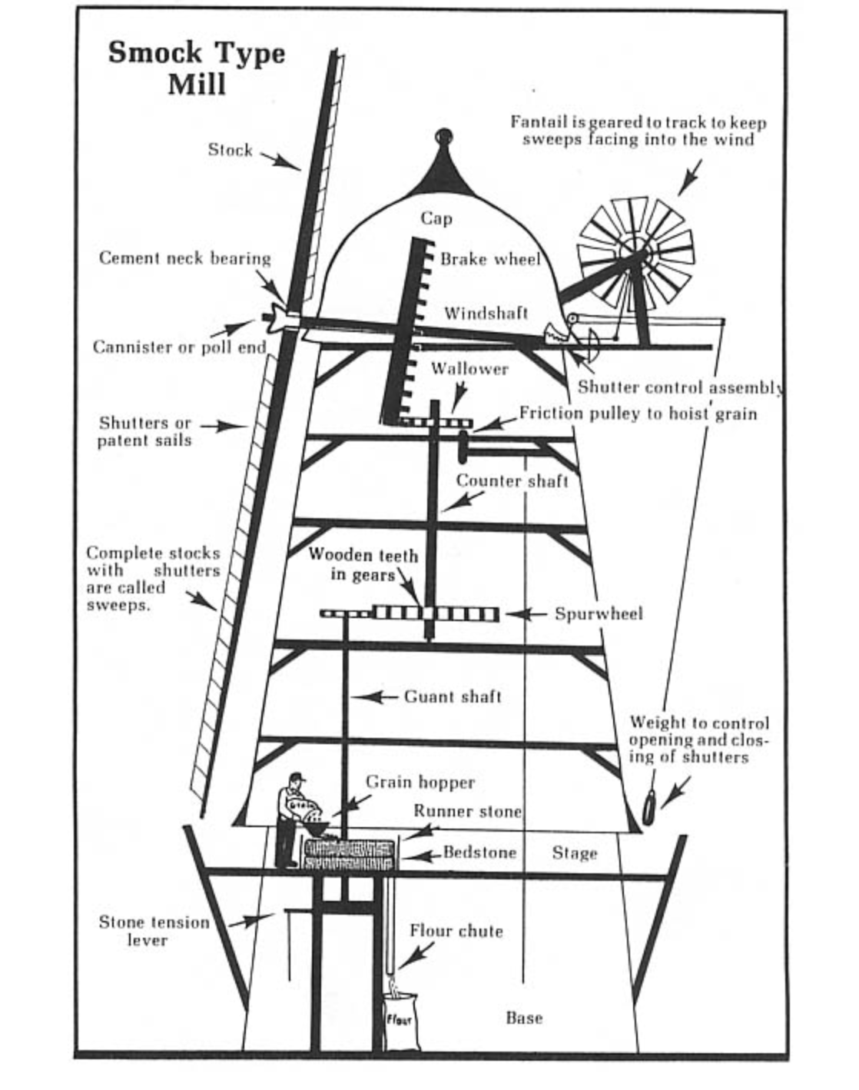

Experiment Work Guide:
Exploring Power
(a review of the windmill video)

How to calculate Power output of machines.

Power is the measure of the rate (time) of which a machine does work

The example in the video:

- Load =.9 newtons (the load were some coins or washers in an evelope)

- He weighed the load with a Newton spring scale.

- Work= force (.9 newtons) x distance (2.5m) (He measured the distance the load traveled from the ground to the top of the windmill).

- Work = 2.25 joules(units of work) (So the amount of work the windmill is doing is measured as 2.25 joules)

Power is the rate of which a machine does work

The Watt is the unit of power

1 Watt= 1 Joule per second

Power = Work/time (Divide the work done by the time it took to do the work).

The windmill completed the work (lifting the load) in 9 seconds

Time = 9 seconds
Important Vocabulary or words to know:
- Unit
- Power
- Rate
- Work
- Newtons
- Joules
- Watt
Power = Work/time

So, to find power divide 2.25 Joules (work) by 9 seconds (time)

Power = .25 Watts power output is .25 watts

What will effect the power output?

A toaster is a 1000 Watt device.
It would take 4000 of these windmills to run the toaster!

Now, let’s measure the amount power your windmill creates:

- Measure the load with the Newton scale
- Measure the distance the load will travel
- Measure the amount of time the load takes to travel from the ground to the top of the windmill.
- Finally calculate the watts
- Remember no naked numbers! Label your numbers with units (ex. 4meters or 4m)
Load or Work | joules
Distance
Time
Watts

Formulas:
Work Space for Calculations
Work= Force x Distance

Work = F_____ x D______
Work =_________joules

Conclusion:

Our windmill produced_________watts of power. We would need __________windmills to power a toaster! (hint: divide the toaster’s watts needed by the amount of Power your windmill produces).
Part2 of this experiment:

Make a modification to your windmill to create more power!
Power= work/time

Power=work_____/time____

Power=_________watts

Comic Book Story Collector Template:

Record your group’s story as you go:
Name:
Table Group:

Setting (describe where the action of your story takes place)
_______________________________________________
_______________________________________________
_______________________________________________
_______________________________________________
_______________________________________________
_______________________________________________

Characters (list and describe the people in your group)
_______________________________________________
_______________________________________________
_______________________________________________
_______________________________________________
_______________________________________________
_______________________________________________

Problem (What problem needs to be solved)
_______________________________________________
_______________________________________________
_______________________________________________
_______________________________________________
_______________________________________________
_______________________________________________

Rising Action (What steps are taken to try to solve the problem)
Step1__________________________________________
_______________________________________________
_______________________________________________Step2__________________________________________
_______________________________________________
_______________________________________________
Step3__________________________________________
_______________________________________________
_______________________________________________

Climax (Will the problem be solved???)
_______________________________________________
_______________________________________________
_______________________________________________
_______________________________________________
_______________________________________________
_______________________________________________

Resolution (How was the problem solved, or not!)
_______________________________________________
_______________________________________________
_______________________________________________
_______________________________________________
_______________________________________________
_______________________________________________

Sketch your Windmill here:

Comic Templates:
