Squishy Circuits Challenge #1
Make a bulb light using only the battery pack, dough, and one LED bulb. Remember to NEVER touch the bulb directly to the battery or wires. Draw ways that work and ways that don’t work.

Squishy Circuits Challenge #2
Make two bulbs light. Draw ways that work, ways that don’t work, and ways that sort of work.

Squishy Circuits Challenge #3
What is the difference between the white dough and the colored dough? Explain how you figured it out.

What differences in the dough might account for the differences in their behavior? Provide support for your ideas.

Try to develop an explanation for why, exactly, the doughs behave differently. You can use online information, expertise in the room, or any other tools at your disposal to develop your explanation (just be sure to credit your sources).

Squishy Circuits Challenge #4
Look at the ways other people in the room have lit their bulbs. Find a way that looks very different than what you have done. Draw what you find below:

Is the bulb lighting the same way in this different design, or in a different way? Try to provide evidence for your answer.

Squishy Circuits Challenge #5
Get a motor to move. What can you get it to do? Draw pictures or diagrams to show what you create. Remember to record ideas that don’t work out as well as those that do!

Squishy Circuits Challenge #6
Build an animal with light up eyes and a spinning tail. Draw a picture of your finished project AND draw a diagram that shows how energy is traveling in your animal.

My Squishy Animal | How Energy Travels In My Squishy Animal

Observe at least two other interesting squishy animals. Record you find below

________________’s Squishy Animal | How The Energy Travels

________________’s Squishy Animal | How The Energy Travels
Squishy Circuits Challenge #7

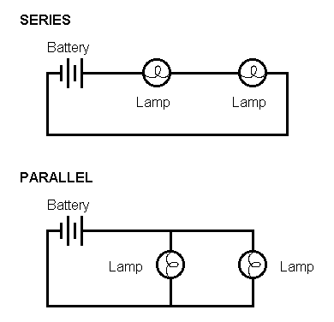
Series Circuit | Parallel Circuit

In what ways are the two different from each other? Explain what differences you find and how you found/ could show the differences.

Is there a difference in how many bulbs each method can light? Any differences in brightness? Explain what you find in words and/ or pictures.
Squishy Circuits Challenge #8
With a partner, explore the Squishy Games idea gallery. Then design your
own game!

Object of the game:

Plan for how the game will work:

Build your game!

Test #1
What went as expected? What was unexpected?

How could you improve your game?
Re-design or revise your game with your new ideas.
Squishy Circuits Challenge #9

What questions or ideas have come up as you have worked with the squishy circuits materials? Design a way to test or further explore one of your ideas.

What I want to test/ explore

How I will test or explore my idea

What I found

