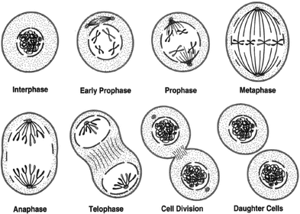 Mitosis Animation Rubric

A Interesting style of names and period
Interesting movie title
Excellent introduction explaining mitosis
All 6 steps of mitosis are shown
Each phase of mitosis is accurately depicted
Cell parts are proportional in size and quantity
Great use of color
Very neat labeling of all parts at each step
Very creative use of the animation
Multiple pictures are taken of each scene, making viewing easy to watch

B Has names and period
Has a movie title
Very good introduction explaining mitosis
All 6 steps of mitosis are show
Each phase of mitosis is accurately depicted
Cell parts are proportional in size and quantity
Good use of color
Neat labeling of all parts at each step
Creative use of the animation
Portions of viewing too fast or too slow

C Has names and period
Has a movie title
Good introduction explaining mitosis
Most steps of mitosis are shown
Most phases of mitosis are accurately depicted
Most cell parts are proportional in size and quantity
Fair use of color
Labeling of all parts at each step
Little animation used
Movie is too fast or too slow overall

