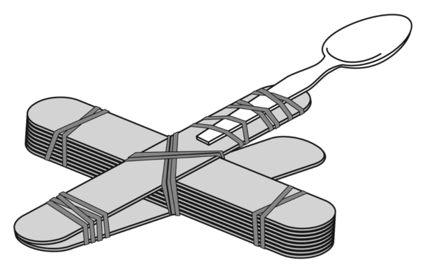

Arm

Fulcrum

Payload

Name _____________________________________________

Marshmallow Catapult

Challenge

Base

Bucket

F o r c e