Getting Started with Engineering Projects
in the Primary Grades
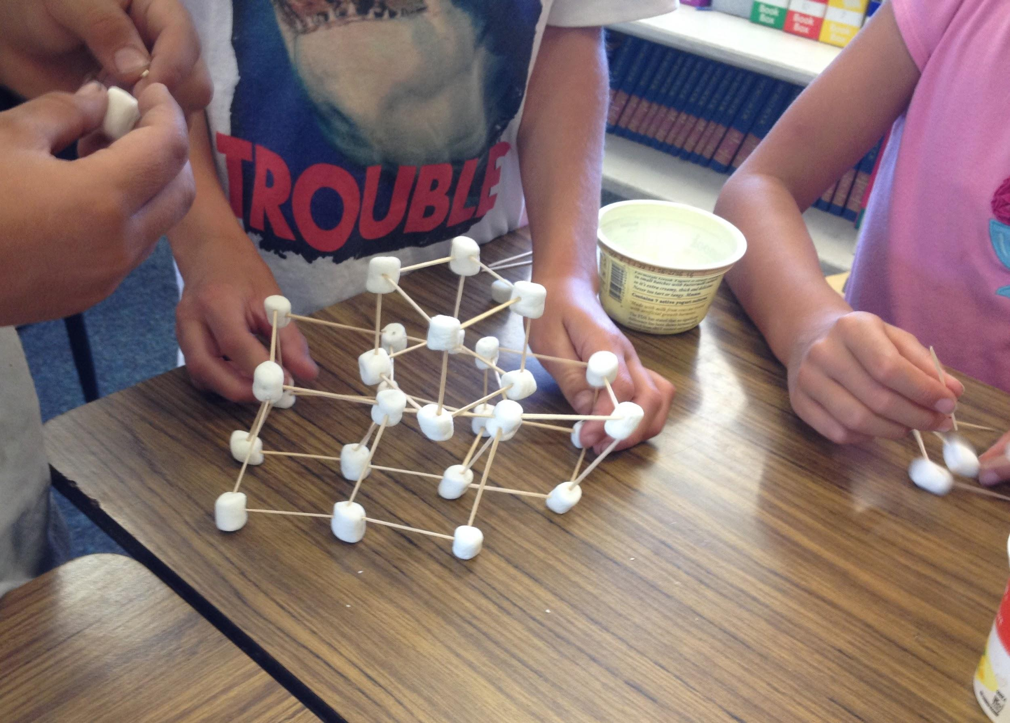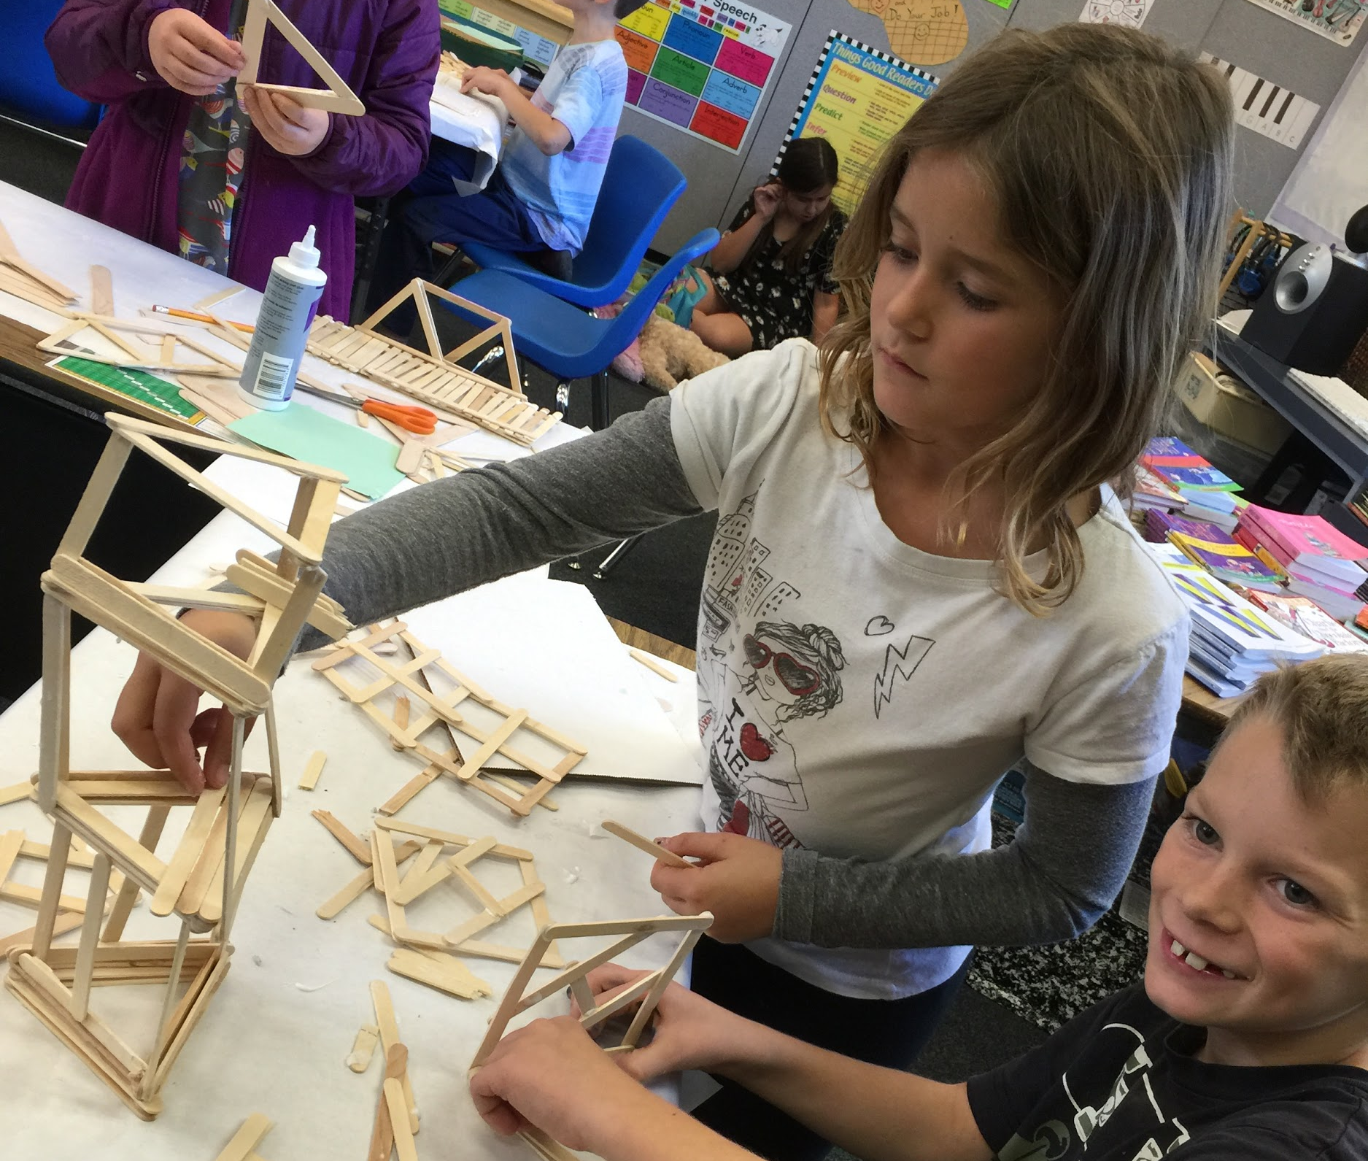
Who is this for ? : All K-3 teachers who are interested in getting started with STEM Projects or finding more ways to implement the NGSS Engineering practices in your classrooms

Why do Engineering? What can students get out of these activities? (Feel free to adapt & share this list with parents at Back to School Night!)
Engineering provides:
- hands-on experience with basic principles of physics & architectural design
- application of mathematical skills (measurement, estimation, counting...)
- connection to real world structures all around us & many different professions
- project based writing & reading opportunities with connections to the many great books out there about "The Way Things Work", houses, historic structures, biographies of great inventors, etc.
- practice in using mathematical & scientific language that is helpful in practical contexts (vertical, horizontal, level, 90 degree angle, balance, area, volume...)
- a positive experience with group cooperative work
- a motivational way to improve communication skills
- activities where students can see the value of precision & accuracy in measurement, how useful geometry can be, and what amazing things people can accomplish with a little scientific knowledge
- a way for students to see that improvement results from multiple attempts at a task and shared knowledge between people
- opportunities for critical thinking, including: spatial reasoning, problem solving, analysis of "failures", application of theory, cross-disciplinary connections, and synthesis of knowledge
- a way that students of all ability and language levels can work together and discover strengths that they didn't always know they had
- a perfect fit with the Common Core, the Next Generation Science Standards, and classroom learning themes
-an attention-grabbing jumping point for lessons & hands-on learning about math, science, technology, social studies & applied arts
- active rather than passive learning
- a highly motivating school experience: Students love it!

What materials & resources do you need to get started?

- math manipulatives & many tools we already have in our classrooms
(pattern blocks, linker cubes, rulers...)
- commonly used classroom supplies & art supplies
(tape, string, scissors, paper, cardboard, pipe cleaners, toothpicks, popsicle sticks, TP tubes, recyclables ...)
- commonly used household objects (pennies, washers, marbles)
- access to the Internet
(go to our local iTeams website or the Exploratorium website, Google "STEM projects", search Youtube or Teacher Tube for easy lesson ideas...)
- any number of hands-on project activities from science adoptions, Foss kits, or the many "great science ideas" books that teachers at your school or the library may have
- patience, flexibility, imagination & an adventurous spirit, or …
a little advance preparation & a standard classroom management plan

A Simple Start-up Lesson: Pattern block towers
Depending upon the attention span of your students and the time you have available, you may choose to do one or more tasks per day. If it seems useful or necessary, you might have your students do multiple iterations of any of the tasks below.
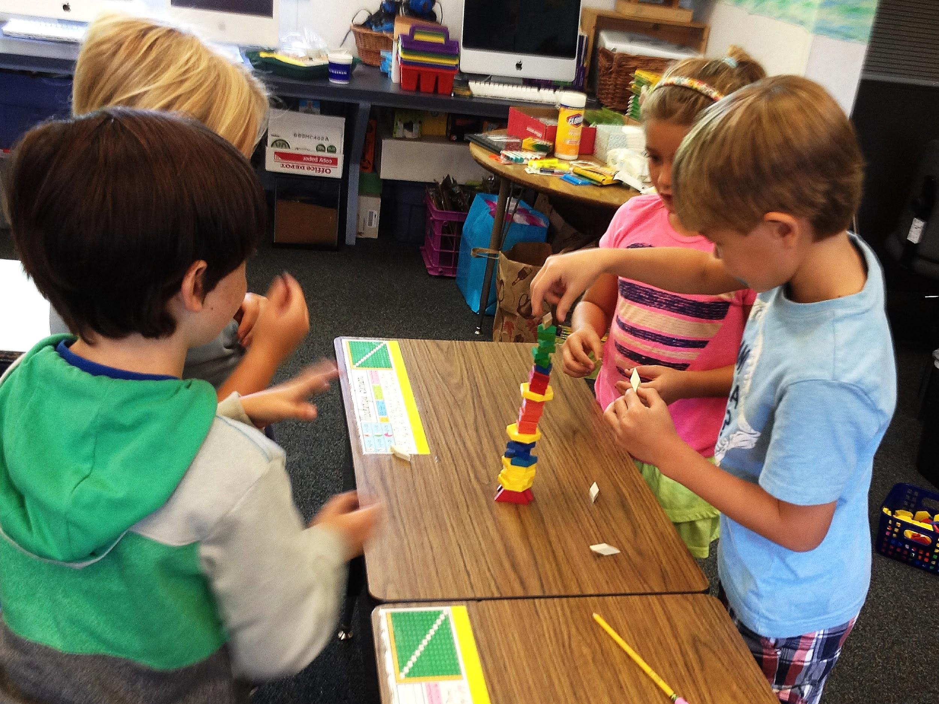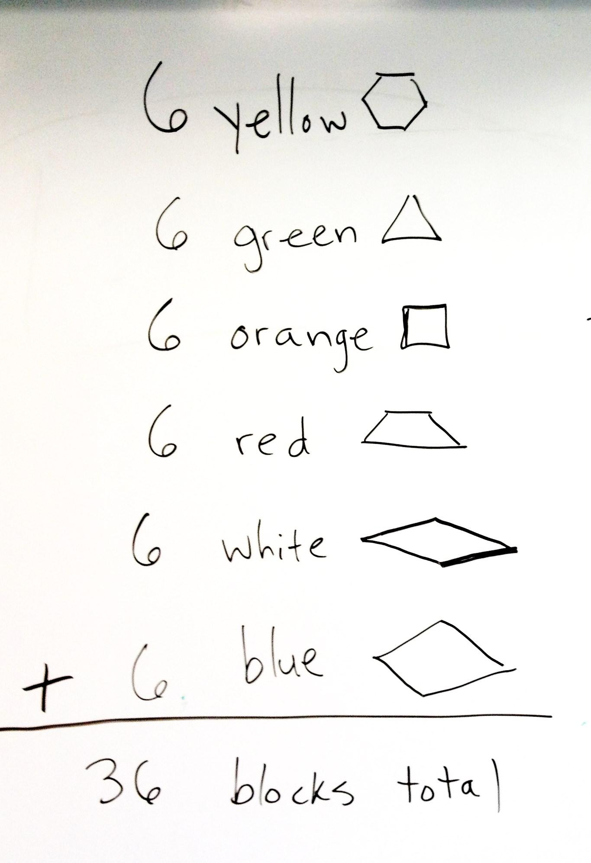

Task 1: Use 6 of each of the six different shapes of blocks to build the highest tower your team can make. (6 yellow hexagons, 6 green triangles, 6 orange squares, 6 red trapezoids, 6 blue rhombuses & 6 white rhombuses)

Suggested time before stopping to measure & debrief: 8 minutes*
Suggested group size: three or four students
materials: 36 pattern blocks for each group (6 of each color/shape)
Debriefing questions: What was the total number of blocks you used? Which towers were the tallest? (measure to verify) Why do you think the block arrangement in each of these towers worked so well? If your tower did not stand up well or get very tall, what changes might you make next time - and why? What was helpful in the way that your group worked together? What was not so helpful? How can we make sure that each group member gets to participate? How can we solve problems the most effectively as we work together to achieve a goal in a short period of time?

* These times, group sizes & debriefing questions are based on a 2nd/3rd grade maturity level. This may need to be changed for K/1st settings.

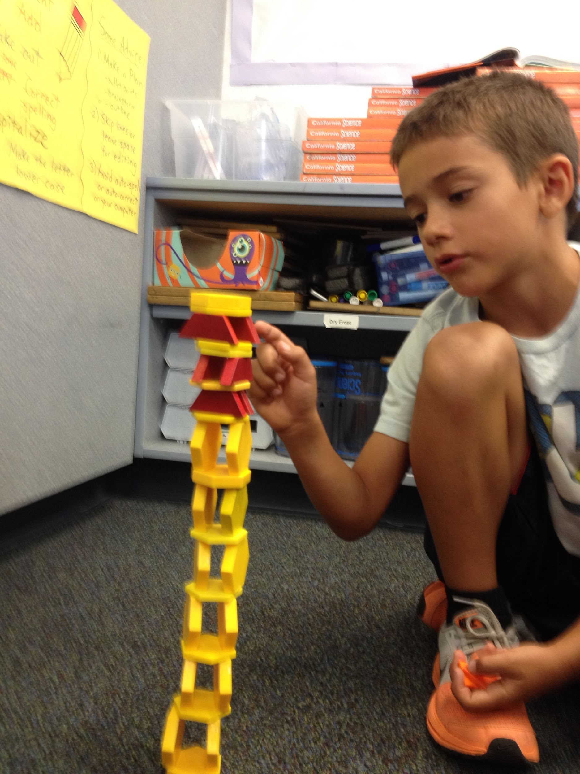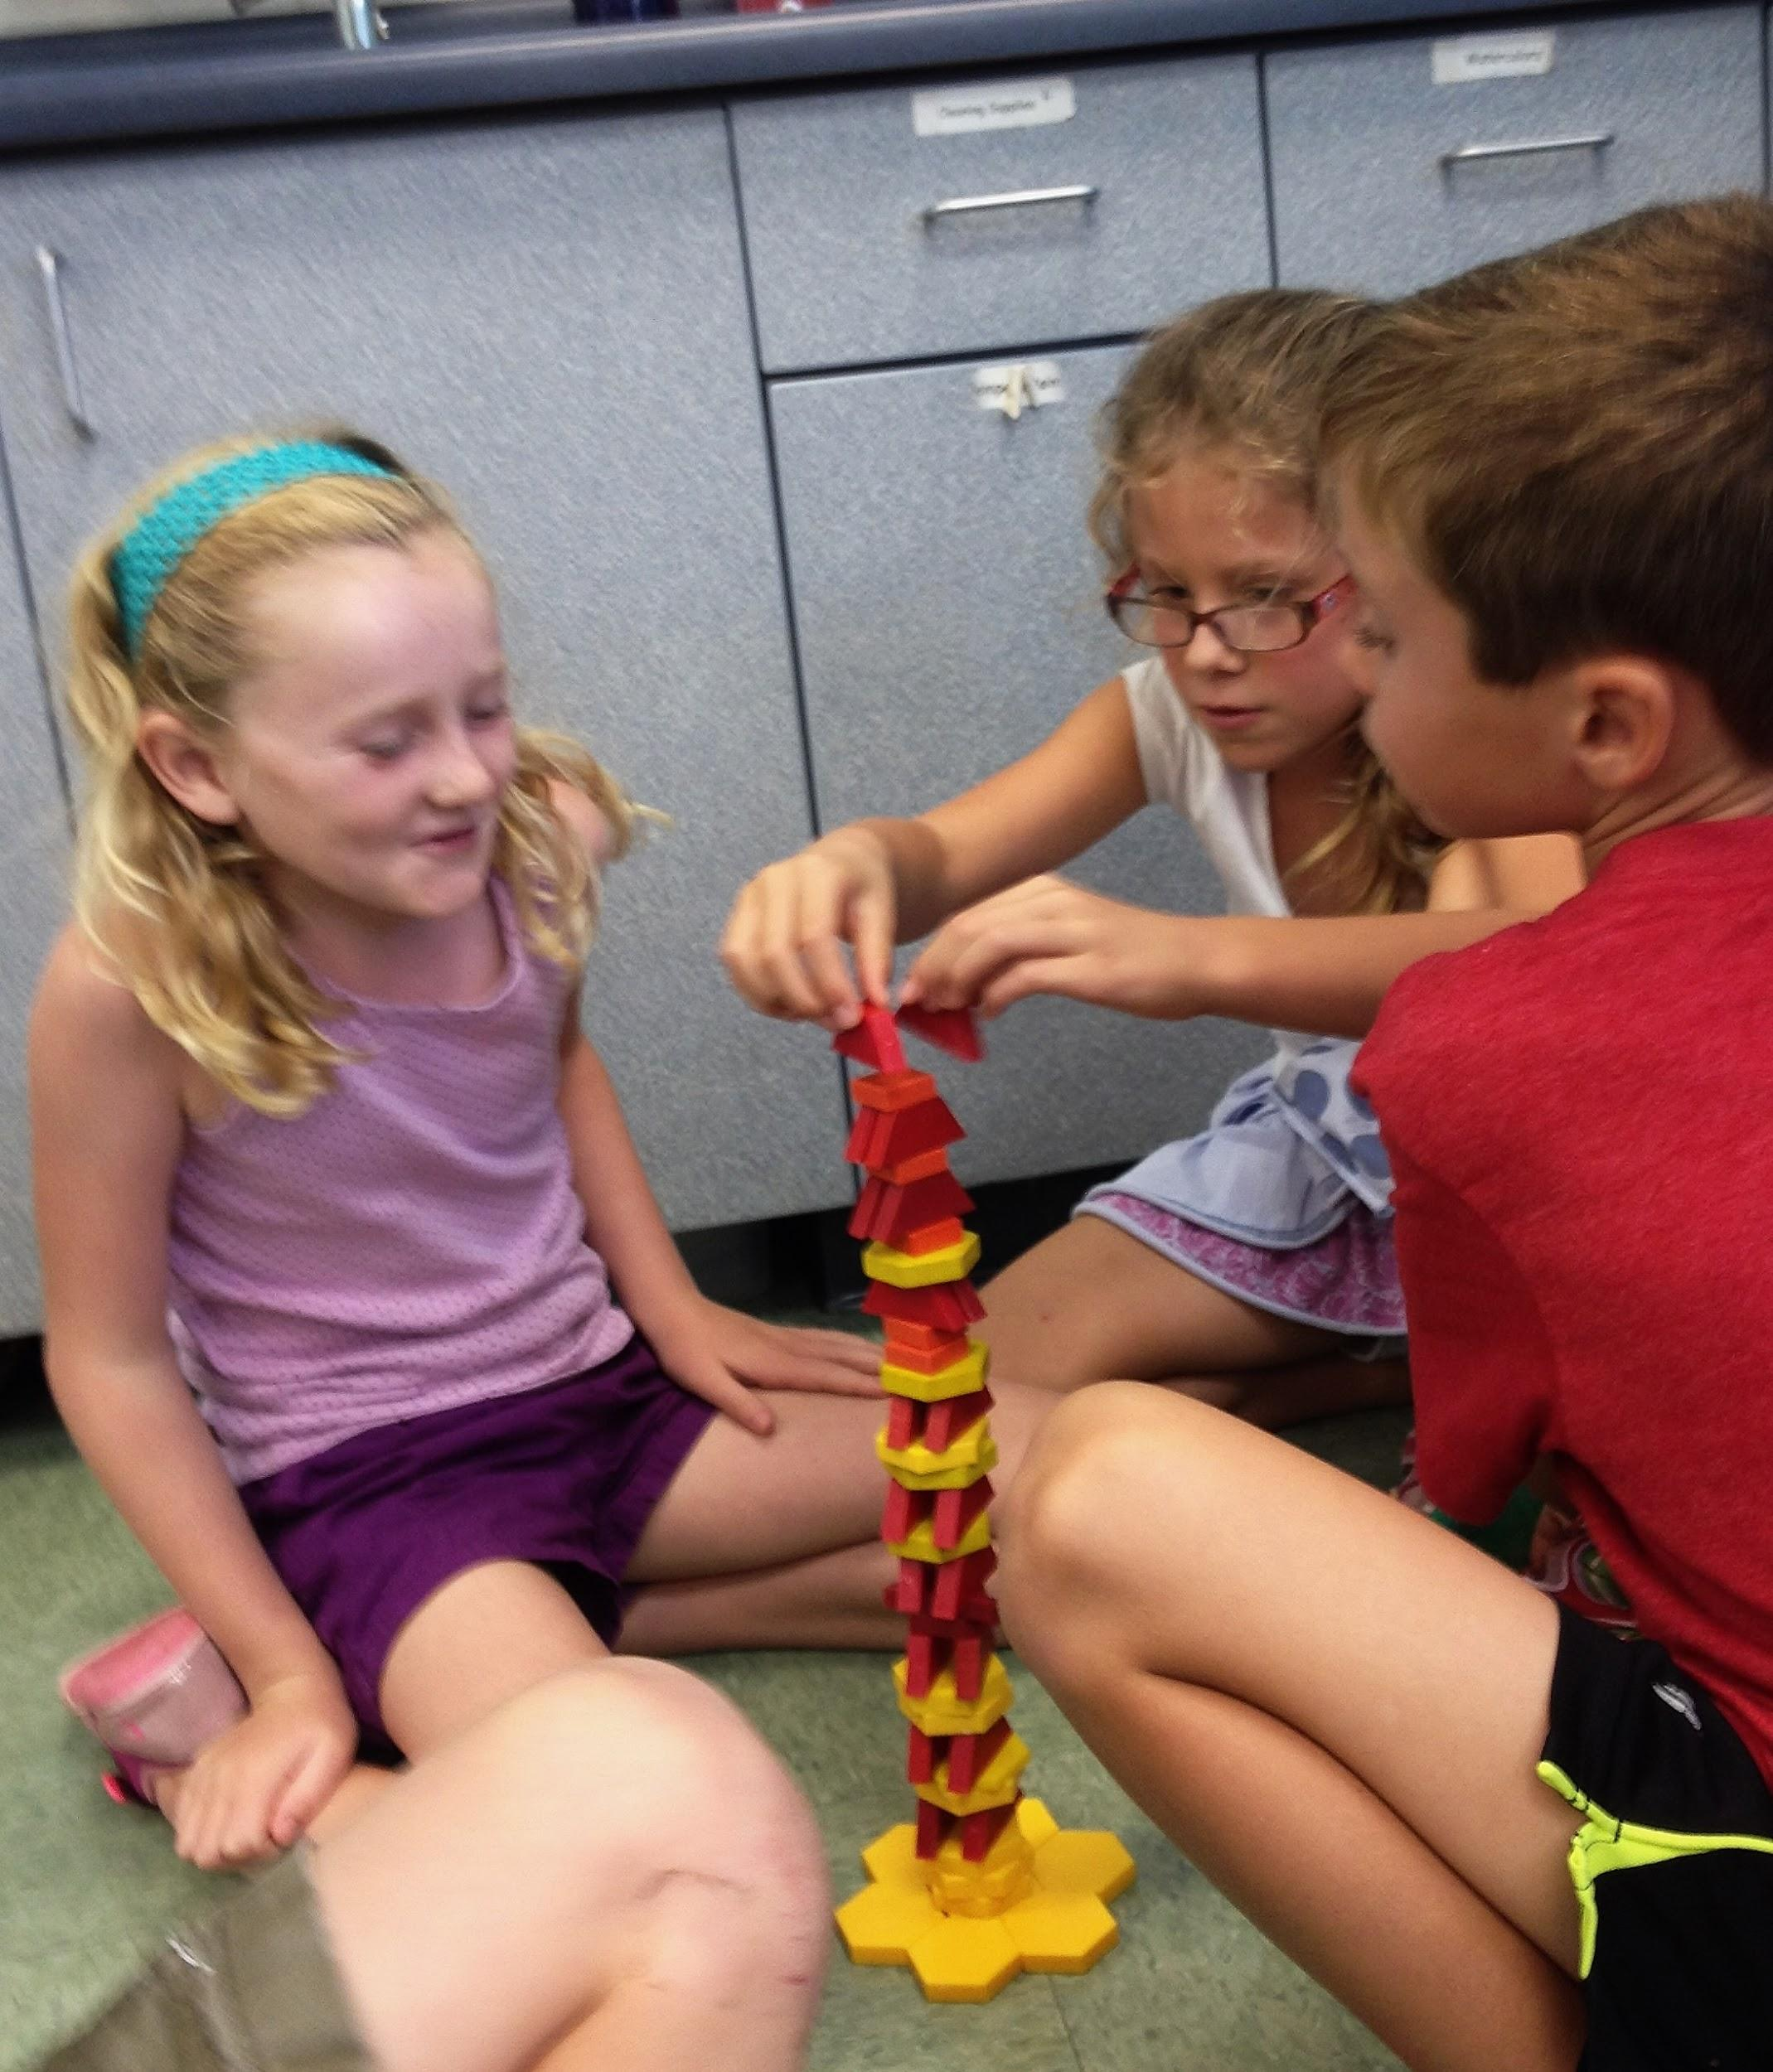

Task 2: Use 36 of whichever combination of blocks that you like to build the tallest tower that your team can make. (Optional/recommended caveat: no more than half of your 36 blocks can be the same color/shape. Have the students determine what the number limit this would give them: half of 36 is...)

Suggested time before stopping to measure & debrief: 8 minutes
materials: bins of pattern blocks accessible to each group that have at least 18 of each color block in them
Debriefing questions: Which towers were the tallest? (measure to verify) Why do you think these towers were the tallest? Which shape blocks seemed to work the best? Why do you think these blocks worked the best? Were there any changes in the way that your group worked together this time? Do you think it's helpful for us to talk about what is working in our building tasks? How is it helpful? What would make it easier to do this task if we did it again?

Optional: reiteration of Task 1 or 2 with a designated planning time before any building was allowed. Suggested planning time:2 to 3 minutes. Suggested building time: 6 to 8 minutes.
Optional recording task: Make a whole class chart/table of the height of each group's tower. Have an individual worksheet that says: "My team's tower was ___ tall. The tallest tower in the class was _____ tall. The difference between the height of my team's tower and the tallest tower was ____. One thing that worked well for our team was __________. One thing that we could improve next time is _______. This is what my team's tower looked like:" (draw picture)

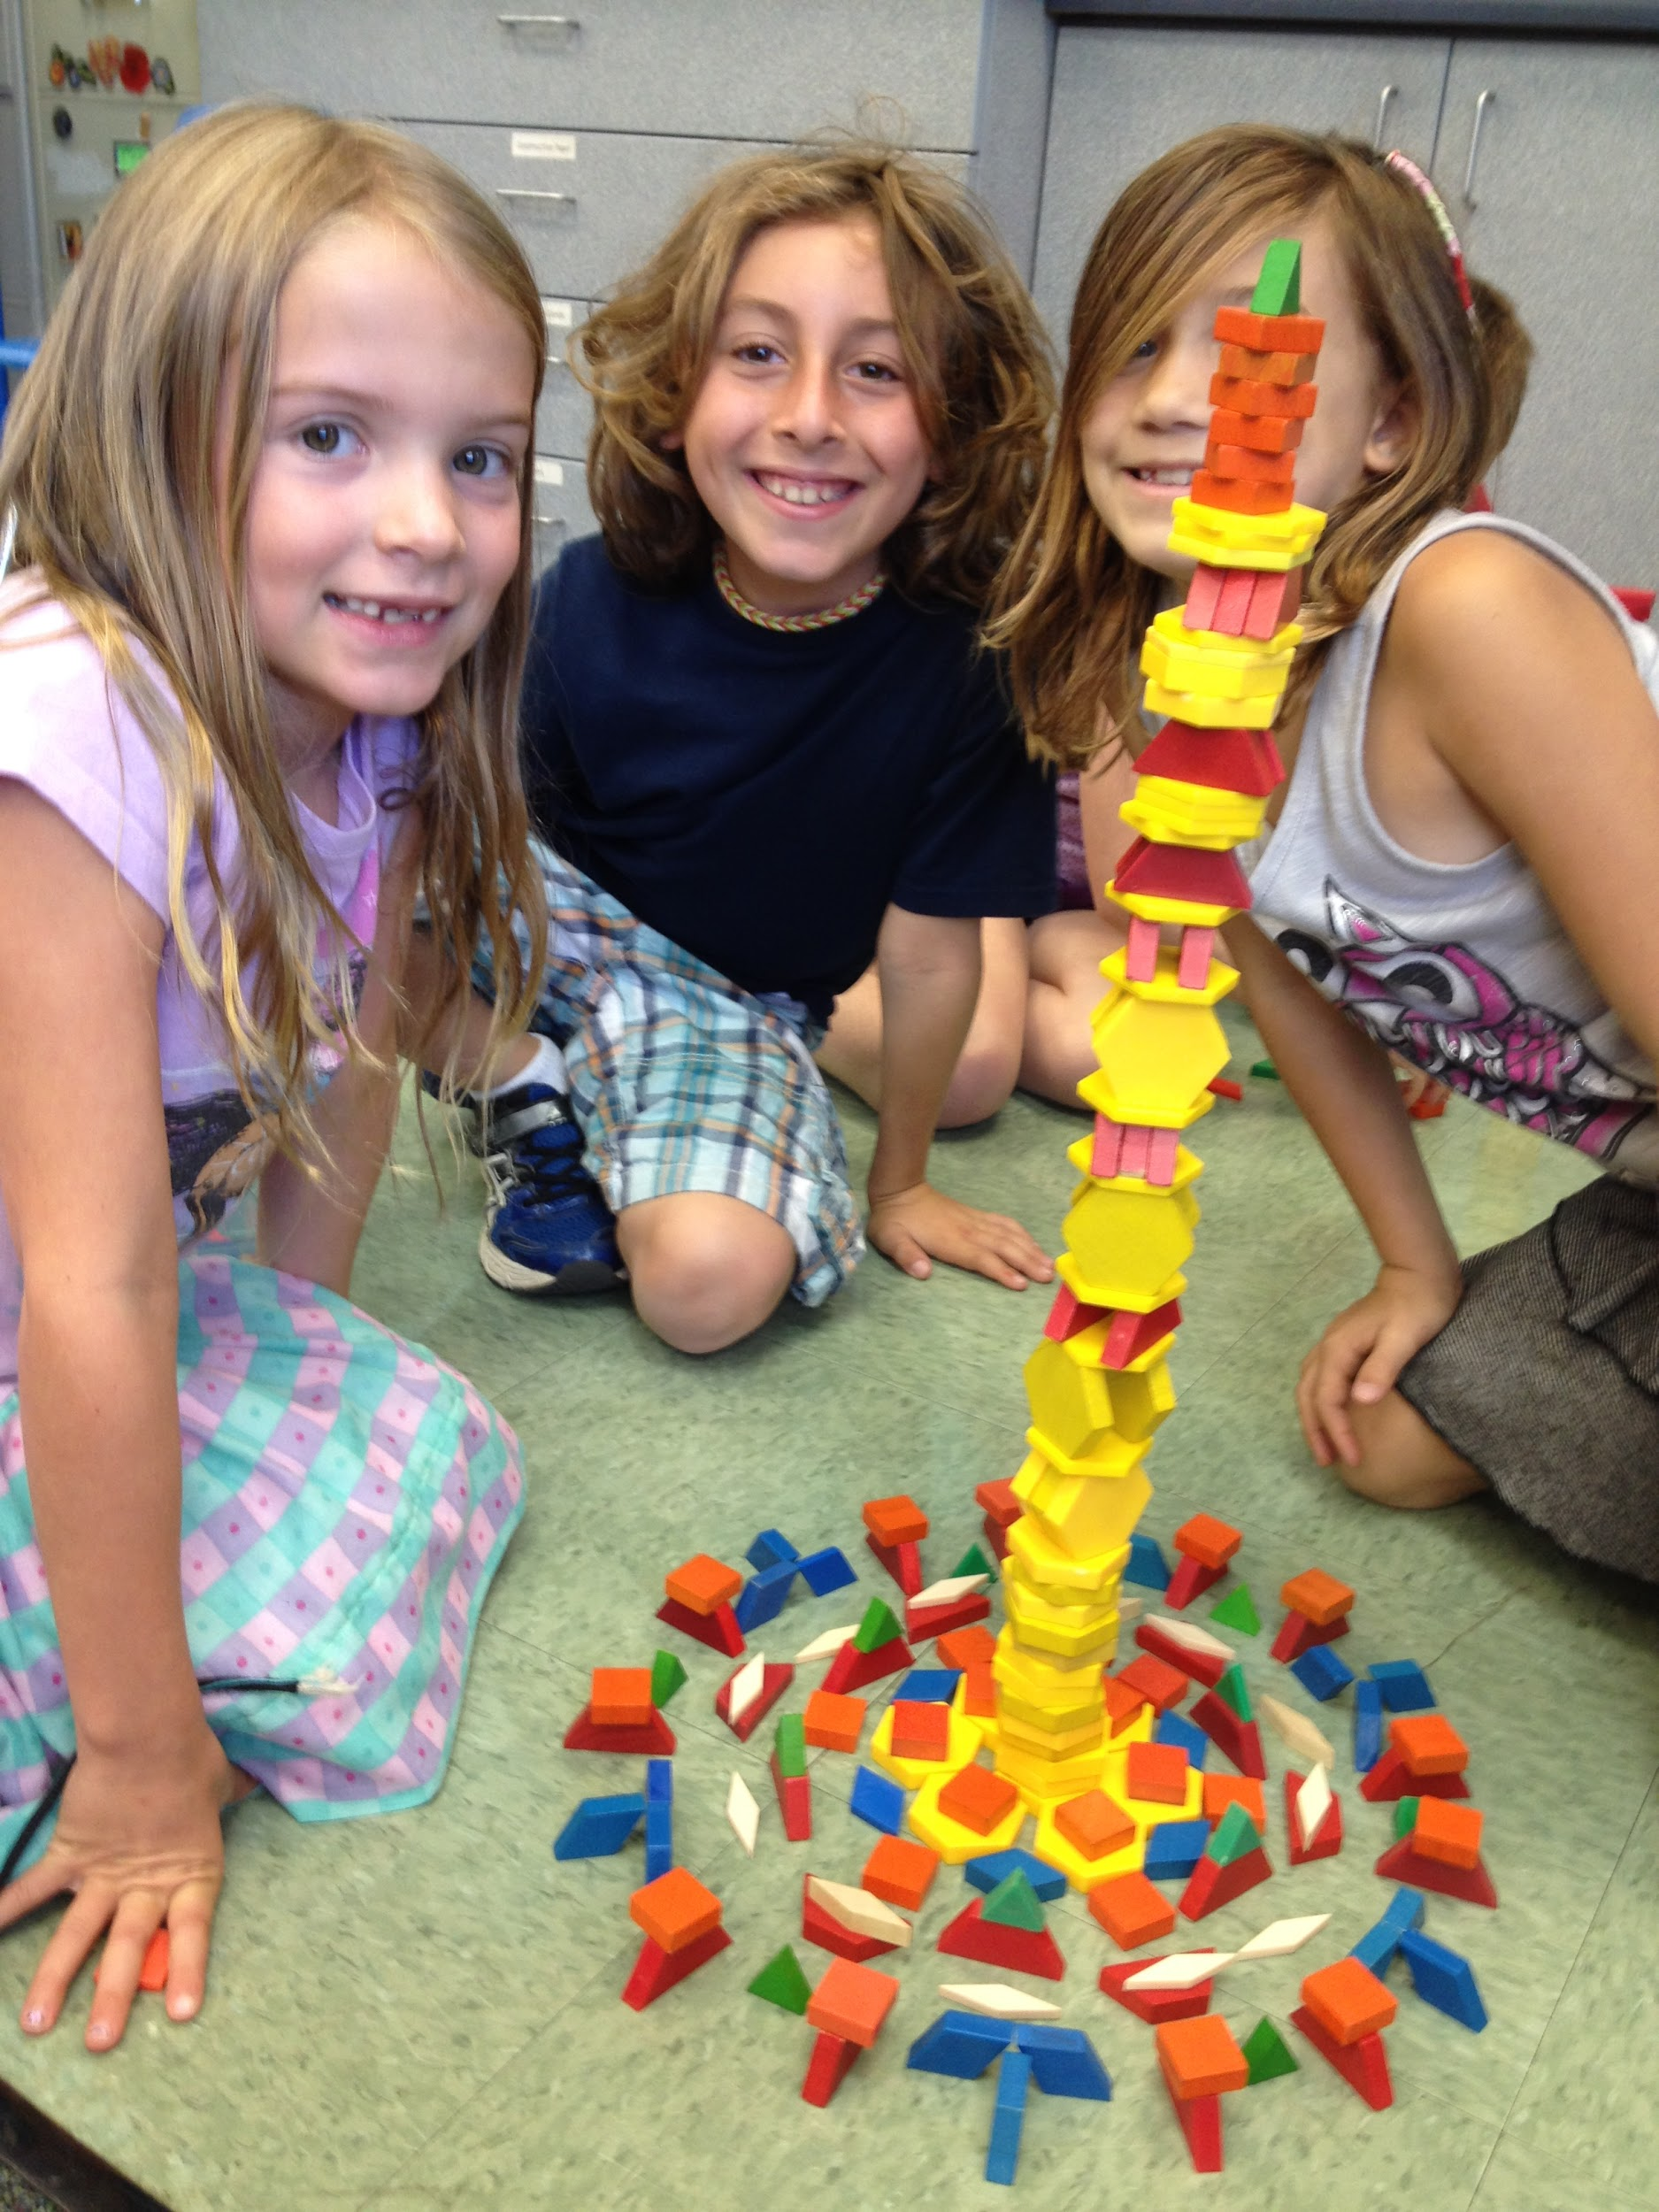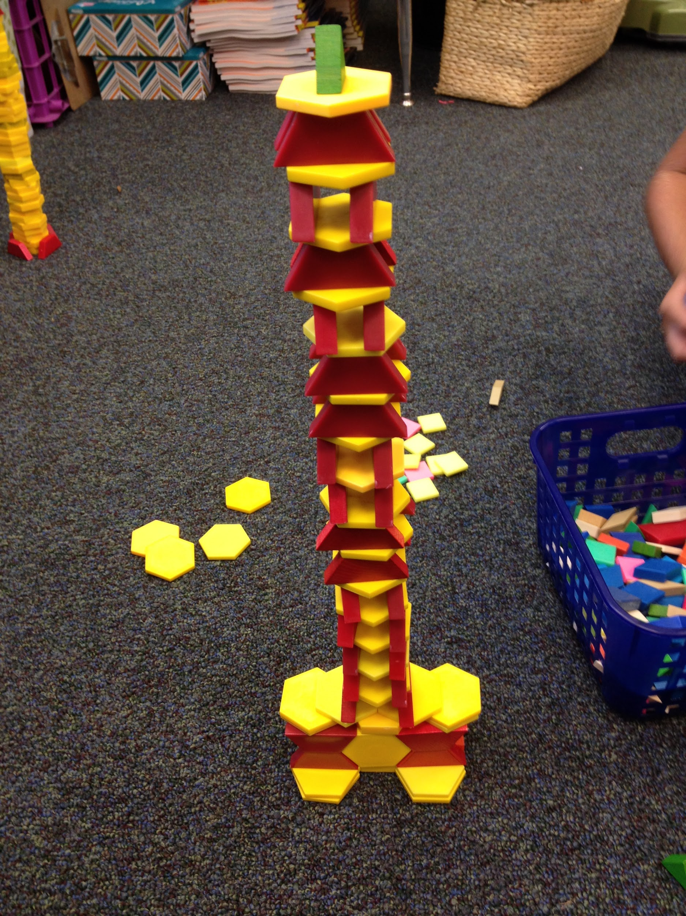
Task 3: Use any number of any color/shape pattern block to build the tallest structure your team can make.
Suggested planning time: 3 minutes
Suggested time before stopping to debrief: 10 minutes
materials: bins for each group with as many blocks as you can rustle up (grade level teams might want to share materials for this strategically), being sure to include a roughly even balance of each type/color of shape in each bin
Debriefing questions: What worked effectively for your team in this task? Did you use anything you learned from the previous block tower building tasks to help you? Did you stick to the ideas you came up with during planning time? Was it helpful to get some time to plan before building? Was it helpful to have more time to build during this task than you had in the last task? If you had even more time, how might that help you to build a taller tower? Which groups had the tallest towers? Why do you think their towers got the tallest? If your team's tower fell over at any point, why do you think this happened? What have we learned about building that we could apply in another task like this? (some language to draw out Socratically: base, support, balanced, unbalanced, vertical, aligned, symmetrical, stable, unstable, width, height...)

Optional: Give each team 10 more minutes to build after the debriefing period. They have the option to add on to their existing structure or rebuild it. Measure each after 10 minutes and debrief again. Did they choose to add or rebuild? Why? How did it work out? Did they apply anything that they learned from other groups? How was their group's work dynamic? Has their group communication & cooperation improved from task to task? How & Why? or Why not?

Extensions/variations:
Take photos of the tower work and have students write about what they discovered.
Have students build with other math manipulatives such as linker cubes and discuss the pros & cons of each type of building material afterward.

Students will get the most out of engineering activities if:
1. Their work objective is clear.
2. Plenty of time is allotted for debriefing & discussion.
3. Student groups have opportunities to do multiple iterations so that they can use what they have learned to improve their designs.
4. The teacher does some explicit instruction of scientific, mathematical or design concepts & vocabulary before, during and/or after the engineering activity to formalize some of the learning.
5. The teacher models use of mathematical, scientific or architectural design vocabulary throughout the activity (Some teachers may like to use sentence strips with discussion prompts to help young learners state their comments in more organized, academic ways.)
6. They have fun and accomplish something!

Please take this simple start and run with it! Feel free to add ideas, share writing formats, discussion prompts or photos of things that have worked in your classroom.
Please feel free to send comments, questions, additions, helpful hints & innovations to me at jflanagan@srcs.org or to our iTeams Director mtodd@srcs.org (iteamsmarin.weebly.com).

Cheers!
John Flanagan
Sun Valley School, San Rafael

PS: If you liked this, please look for my next article in this series: Sticks, Straws, String & Structural Geometry!

PPS: The main 3rd-5th Next Generation Science Standard the lesson above addresses is…

3-5-ETS1-2 :Generate & compare multiple possible solutions to a problem based on how well each is likely to meet the criteria and constraints of the problem.

Observable features of the student performance by the end of the grade: 1) Using scientific knowledge to generate design solutions,
a) Students use grade-appropriate information from research about a given problem, including the causes and effects of the problem and relevant scientific information.
b) Students generate at least two possible solutions to the problem based on scientific information and understanding of the problem.
c) Students specify how each design solution solves the problem.
d) Students share ideas and findings with others about design solutions to generate a variety of possible solutions.
e) Students describe the necessary steps for designing a solution to a problem, including conducting research and communicating with others throughout the design process to improve the design [note: emphasis is on what is necessary for designing solutions, not on a step-wise process].
2) Describing criteria and constraints, including quantification when appropriate - Students describe: i. The given criteria (required features) and constraints (limits) for the solutions, including increasing benefits, decreasing risks/costs, and meeting societal demands as appropriate. ii. How the criteria and constraints will be used to generate and test the design solutions.
3) Evaluating potential solutions
a) Students test each solution under a range of likely conditions and gather data to determine how well the solutions meet the criteria and constraints of the problem.
b) Students use the collected data to compare solutions based on how well each solution meets the criteria and constraints of the problem.

