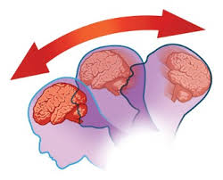
Research On Brain Concussions

Directions: Using at least 3 different, valid internet sites and working with your partner, find answers to the following questions. Write your own answers on your binder paper.

1. What is a brain concussion?
2. What are a number of causes of brain concussions? Explain these not just make a list. How does that particular incident cause the brain concussion?
3. What are some consequences of a person having multiple (more than 1) concussions in their lifetime?
4. What medical steps should be taken if you have a concussion, especially a serious concussion?
5. How can concussions be prevented?
6. Can you find some examples of the latest gear that can be prevented?
7. What sports have the highest number of concussions? If you are wearing a helmet, can you still get a serious concussion? Would it be worse without the helmet?
8. List your 3 or more websites.

Possible video resources to check: http://brain101.orcasinc.com/5000/
http://www.cbsnews.com/news/basketball-concussions-a-risk-in-contact-sports-not-just-football/
http://www.ted.com/talks/kim_gorgens_protecting_the_brain_against_concussion#t-216986
http://www.pbs.org/wgbh/pages/frontline/league-of-denial/

Now that you have discovered some of the serious effects of a concussion or repeated concussions in someone’s life, be prepared for your next engineering challenge.

You and your team will need to design and build a football helmet that prevents concussions. More details will be explained on Monday, but here’s a few deets to have you think about what materials you and the team need to bring in to build your helmet:
- A raw egg will be the head and brain.
- The helmet must be able to be put on and taken off easily, like any helmet!
- The helmet must resemble a helmet: visor, strap, neck is exposed.

